Project Design Phase-II

Data flow Diagram and User Stories

|  |  |
| --- | --- |
| **Date** | 17 October 17, 2022 |
| **Project Name** | Web Phishing Detection |
| **Maximum Marks** | 4 Marks |
| **Team ID** | PNT2022TMID52729 |

# Data Flow Diagrams:

A Data Flow Diagram (DFD) is a traditional visual representation of the information flows within a system. A neat and clear DFD can depict the right amount of the system requirement graphically. It shows how data enters and leaves the system, what changes the information, and where data is stored.

DFD Level 0:

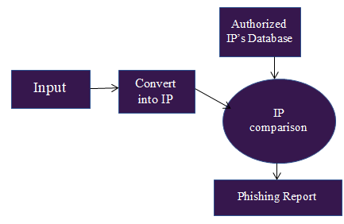

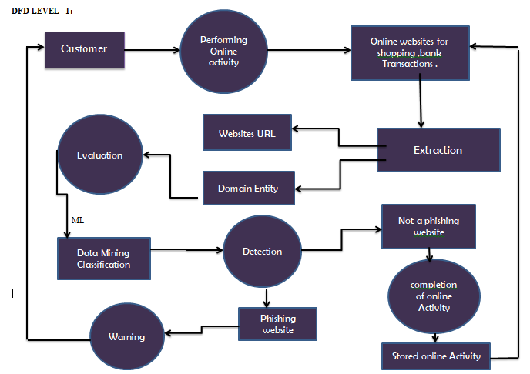

# User Stories

Use the below template to list all the user stories for the product.

|  |  |  |  |  |  |  |
| --- | --- | --- | --- | --- | --- | --- |
| **User Type** | **Functional**  **Requirement**  **(Epic)** | **User Story Number** | **User Story / Task** | **Acceptance criteria** | **Priority** | **Release** |
| Customer  (Mobile user) | User Input | USN-1 | User can input the particular URL | Access website without caution. | High | Sprint -1 |
| Customer (Web user) | User Input | USN-1 | As a user i can input the particular URL in the required field and waiting for validation. | Access website without caution. | High | Sprint -1 |
| Customer Care Executive | User Input | USN-1 | The model must extract appropriate features from the URL given by the user. | User can have comparison between websites. | High | Sprint -1 |
| Administrator | Predictions | USN-1 | Model must use an ML algorithm such as KNN, Logistic regression etc to make predictions. | Correct prediction on particular algorithms. | High | Sprint -1 |
|  | classifier | USN-2 | This data is then provided to the classifier to make the final decision | Find the correct classifier for producing the result. | High | Sprint -2 |